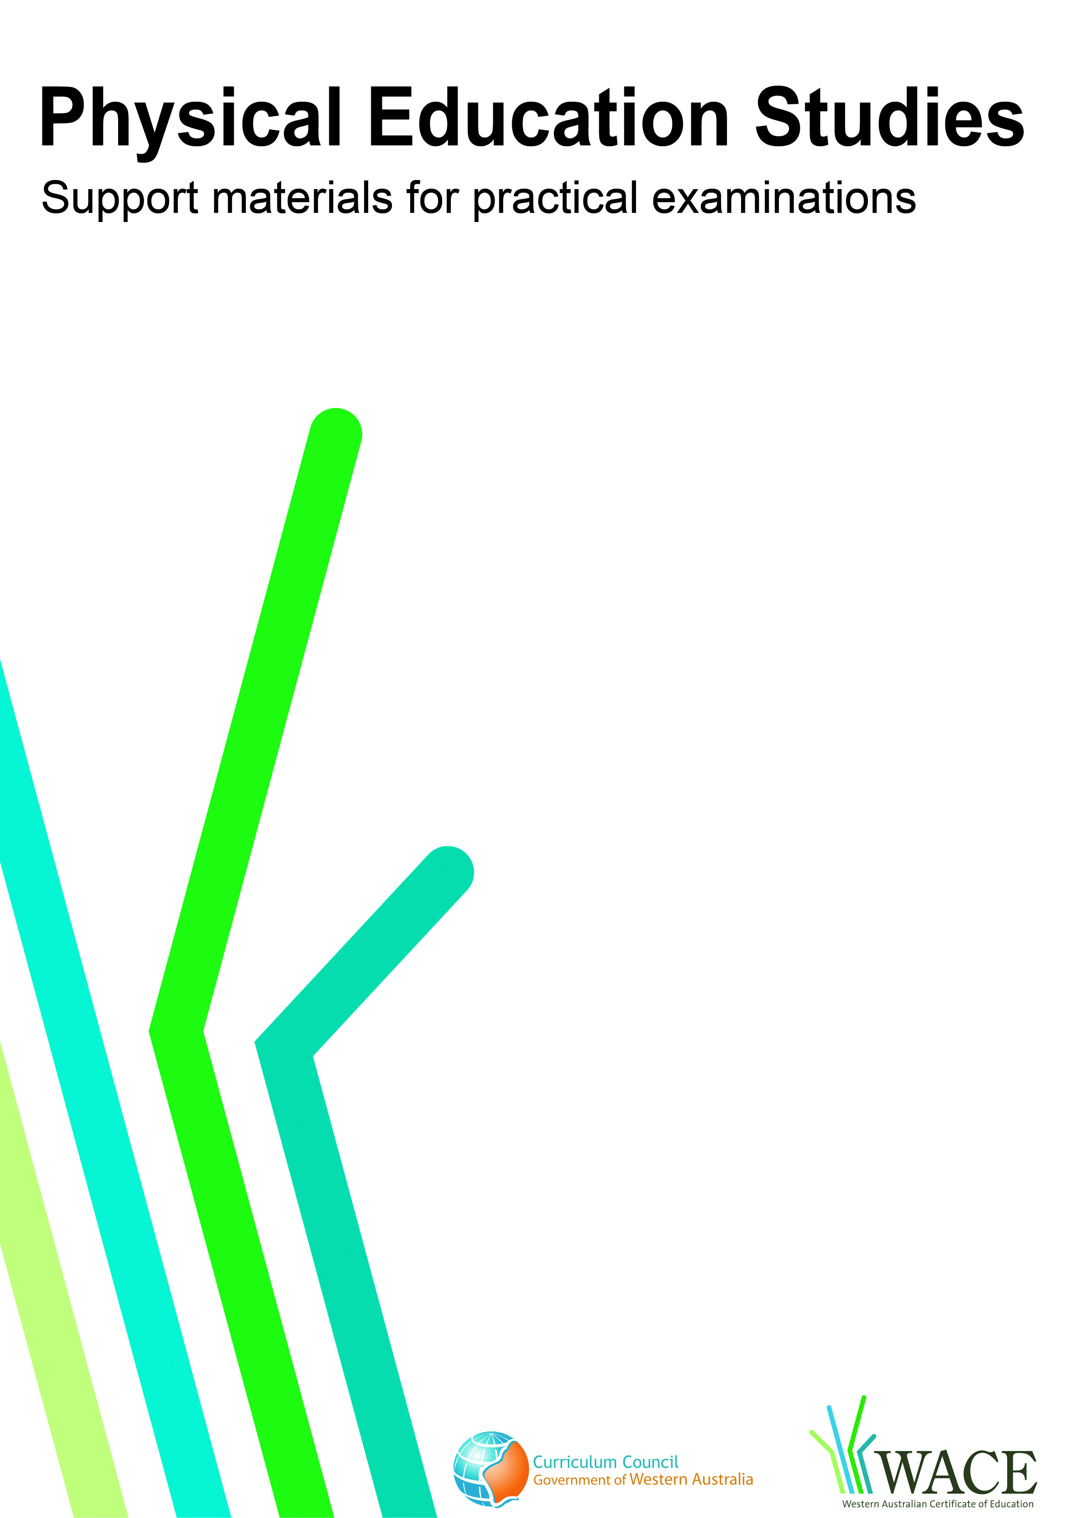

Netball

© Curriculum Council, 2009
This document—apart from any third party copyright material contained in it—may be freely copied, or communicated on an intranet, for non-commercial purposes by educational institutions, provided that it is not changed in any way and that the Curriculum Council is acknowledged as the copyright owner.
Copying or communication for any other purpose can be done only within the terms of the Copyright Act or by permission of the Curriculum Council.
Copying or communication of any third party copyright material contained in this document can be done only within the terms of the Copyright Act or by permission of the copyright owners.

© Curriculum Council, 2011
This document—apart from any third party copyright material contained in it—may be freely copied, or communicated on an intranet, for non-commercial purposes by educational institutions, provided that it is not changed in any way and that the Curriculum Council is acknowledged as the copyright owner.
Copying or communication for any other purpose can be done only within the terms of the Copyright Act or by permission of the Curriculum Council.
Copying or communication of any third party copyright material contained in this document can be done only within the terms of the Copyright Act or by permission of the copyright owners.
Version 5

Introduction
The purpose of these materials is to support teachers and candidates in preparation for the Physical Education Studies practical examination.

Skills set for netball
These materials outline the examinable skills set for netball. Five (5) of the skills, selected by the examination panel, will be examined and these will be communicated to the candidates at the commencement of the examination.

Observation points
Observation points are provided for each skill in the skills set. They are provided for the purpose of teaching and coaching and are designed to assist examination candidates in their personal skill development.

Examination drills
The examination will contain a number of drills through which the selected skills will be assessed. These materials outline a number of drills indicative of the types of drills in which the candidates will participate during the examination and may form part of a teaching program.

Tactical framework
In the conditioned performance section of the examination, candidates will participate in a modified competitive situation, which will be based on some of the tactical problems in netball. The tactical problems for the examination are outlined in the tactical framework and will be selected by the examination panel. The skills that provide the basis for the solutions to these tactical problems are also included in the framework.

In the conditioned performance section of the netball examination, students will be assessed on the execution of skills, use of space, positioning and decision making that effectively solve the tactical problems presented by the modified competitive situation.

Specialist skills
Contained within this document are a number of skills that have been identified as having a degree of specialisation. They are skills that some students may choose to focus on. These skills are included within this document as they may form part of a teaching program; however, they will not be included in the Physical Education Studies practical examination.

CONTENTS | PAGE NUMBER
Netball skills set | 5
Skills set and observation points | 6
Netball drills | 14
Drill descriptions | 15
Tactical framework | 33

Skill number | Name of skill | Page number
1 | Shoulder pass | 6
2 | Chest pass | 6
3 | Bounce pass | 6
4 | Lob pass | 7
5 | Two-foot land | 7
6 | Split and re-offer | 8
7 | Front cut | 8
8 | Dodge | 9
9 | Shadowing | 9
10 | First ball – defence intercept | 9
11 | 3 feet (0.9m) recovery | 10
12 | Dictating | 10
13 | Outside foot land and pivot | 11
14 | Specialist skill: Goal shooting  (not examined externally) | 11
15 | Specialist skill: Defence of shot at goal  (not examined externally) | 12
16 | Specialist skill: Centre court driving onto goal circle and landing  (not examined externally) | 13

1. SHOULDER PASS
Preparation | Execution | Completion
- Body is balanced with a stable trunk  - Opposite foot to throwing arm is forward  - Feet are shoulder-width apart  - Ball is held in two hands with fingers spread wide behind the ball | - Arms lead trunk in rotation towards the throwing side  - Ball is transferred to one hand with arm back behind the shoulder  - Elbow is away from the hip  - Weight is transferred forward as throwing arm moves through  - Hips and shoulders rotate towards the target  - Lead foot steps forward towards the target | - Optimal angle of release with appropriate force transferred to ball  - Arm follows through; wrists and fingers extend in direction of the target  - Ball flight has a flat trajectory
2. CHEST PASS
Preparation | Execution | Completion
- Body is balanced upright with a stable trunk  - Front-on to the target  - Ball is held with two hands at chest height  - Fingers are spread around the ball, thumbs behind with elbows in | - Flexion of elbows to draw the ball towards the chest  - Force is transferred by stepping toward the target transferring weight to front foot  - Simultaneously pushing the ball with wrists and fingers  - Ball is released evenly from both hands | - Optimal angle of release with force transferred to the ball with full arm extension and wrist flick  - Arms follow through; wrists and fingers extend in direction of the target  - Ball flight has flat trajectory
3. BOUNCE PASS
Preparation | Execution | Completion
- Body is balanced with stable trunk  - Feet are shoulder-width apart  - Ball is held in both hands with fingers spread wide on the ball | - Flexion of elbows to draw ball towards the chest  - Weight is transferred forward onto opposite foot  - Low body position is maintained throughout the action  - Front foot leads towards the target  - Ball is transferred to one hand  - Arm is extended so the ball is placed into the space 2/3 of the way to target | - Optimal angle of release with force transferred to the ball  - Arm follows through; wrists and fingers extend in direction of the target  - End height of the ball after bounce equal to knee height of the receiver

4. LOB PASS
Preparation | Execution | Completion
- Body is balanced with a stable trunk  - Opposite foot to throwing arm is forward  - Feet are shoulder-width apart  - Ball is held in two hands with fingers spread wide behind ball | - Ball is transferred to one hand with arm back behind the shoulder  - Weight is transferred forward as throwing arm moves through  - Hips, shoulders and leading foot rotate towards the target  - Optimal angle of release to achieve accurate delivery of the pass Ball is released at its highest point | - Ball flight has parabolic trajectory  - Arm follows through; wrists and fingers extend in direction of the target
5. TWO-FOOT LAND
Preparation | Execution | Completion
- Strong lead to the ball  - Body is balanced upright with a stable trunk  - Shoulders are square and chin is up  - Arms are extended towards the ball | - Impact on landing is even between both feet  - Hips, knees and ankles are flexed  - Land with a wide stance  - Body weight is transferred over both feet with shoulders even  - Ball is received in front of the body so player runs onto the ball  - Fingers are spread with thumbs behind the ball, forming a ‘W’ with index fingers  - Ball is brought into the body to absorb impact | - Balance is maintained to prevent illegal movements  - Target for next pass is anticipated

6. SPLIT AND RE-OFFER
Preparation | Execution | Completion
- Body is upright and trunk is stable  - Knees and hips are slightly flexed  - Shoulders are square and chin is up  - Eyes are on the thrower | - Outside foot is placed strongly on the ground with adequate transfer of force in the opposite direction  - Change of direction is appropriately timed  - Hips turn inside towards the ball  - Force is transferred sequentially through legs, trunk and arms throughout motion  - Strong drives on both leads  - Run on to catch in front  - Fingers are spread with thumbs behind ball, forming a ‘W’ with the index fingers | - Strong sharp take of the ball in preparation for next pass
7. FRONT CUT
Preparation | Execution | Completion
- Body is upright and trunk is stable  - Knees and hips are slightly flexed  - Shoulders are square and chin is up  - Sprinting action is fast and efficient  - Ball side drive | - Two to three fast accelerated steps taken away from the intended catching direction  - Outside foot is placed strongly on the ground in preparation for push off  - Adequate transfer of force in the opposite direction  - Fast, sharp acceleration after change of direction towards receipt of the ball  - Pass is released as attacker runs past defender’s shoulder  - Ball is passed in front of attacker to run onto  - Fingers are spread with thumbs behind ball, forming a ‘W’ with index fingers | - Strong sharp take of the ball in preparation for next pass

8. DODGE
Preparation | Execution | Completion
- Body is upright and trunk is stable  - Knees are slightly flexed  - Eyes are on the thrower | - Dynamic lateral move, pushing off outside foot Outside foot is planted to transfer force in the opposite direction  - When cutting off defender, angle towards the ball  - Accelerate onto the catch  - Pass is released as attacker runs past defender’s shoulder  - Ball is passed in front of attacker to run onto  - Fingers are spread with thumbs behind ball, forming a ‘W’ with index fingers | - Sharp movement  - Strong take of the ball in preparation for next pass
9. SHADOWING
Preparation | Execution | Completion
- Body is balanced with feet shoulder-width apart  - Knees are flexed  - Weight is slightly forward over the toes  - Back is upright | - Back is to attacker with use of peripheral vision to track opponent  - Positioned to cover half of opponent’s body  - Arms are close to the body  - Trunk twists slightly as shoulders open to play  - Chin and eyes are up Head is positioned to see both ball and opponent (45° ) | - Small steps with fast feet to shadow player  - Uses slide step to maintain balance  - Receipt of pass and/or movement of opponent is prevented

10. FIRST BALL – DEFENCE INTERCEPT
Preparation | Execution | Completion
- Body is upright and trunk is stable  - Knees and hips are slightly flexed  - Shoulders are square and chin is up  - Sprinting action is fast and efficient | - Back is to attacker for starting position; covering half of the opponent’s body, forcing them away from the ball  - Strong upright body position is maintained throughout the shadow phase  - On release of the ball, run through to intercept the ball  - Eyes focus on the ball  - Arms extend to meet the ball  - Fingers are spread with thumbs behind ball, forming a ‘W’ with index fingers | - Land and balance to outlet pass
11. 3 FEET (0.9M) RECOVERY
Preparation | Execution | Completion
- Adequate transfer of force in the opposite direction  - Strong stride/jump back  - Weight is balanced over two feet  - Hips, knees and ankles are slightly flexed | - Arms are up and in a position appropriate to dictate desired direction of pass  - Weight is balanced on the balls of the feet  - Body leans forward from the hips  - Eyes are up, tracking the ball and play | - Repositions quickly to defend attacker’s moves
12. DICTATING
Preparation | Execution | Completion
- Body is balanced with feet shoulder-width apart  - Knees are flexed  - Weight is slightly forward over the toes  - Back is upright | - Arms are close to the body  - Standing front-on to the attacker  - Head is up  - Head is positioned to see the opponent and ball  - Solid base of support  - Angle body to force opponent away from the ball  - Footwork is fast and effective | - Opponent prevented from receiving the ball

13. OUTSIDE-FOOT LAND AND PIVOT
Preparation | Execution | Completion
- Body is upright and trunk is stable  - Knees are slightly flexed  - Lead on 45° angle  - Leading leg and arms extend towards the ball  - Eyes focus on the thrower | - Land on ball of foot of outside leg Impact is taken through outside foot  - Flexion through the knee, hip and ankle  - Follow with landing of second foot quickly to absorb remainder of forces of landing  - The attacker is to drive onto the ball which is thrown/placed into space  - Fingers are spread with thumbs behind ball, forming a ‘W’ with index fingers  - Allow force in the ball to assist in taking body around in turn  - Pivot on ball of the outside foot  - Strong through the trunk | - Balance is maintained to prevent illegal movements  - Target for next pass is anticipated
14. SPECIALIST SKILL: GOAL SHOOTING (not examined externally)
Preparation | Execution | Completion
- Ball is held in one hand with fingers spread Ball sits on middle of fingers (not on the palm)  - Other hand supports on the side of the ball  - Arm is high  - Feet are shoulder-width apart  - Feet, hips and shoulders are square to post  - Aim at the goal | - Knees are evenly flexed  - Elbow is slightly flexed  - Push up with the legs strongly to toes  - Elbow towards the post  - Arm extends and follow through is with wrist and fingers on release of the ball  - Ball is released high | - Stable base is maintained  - Arm is fully extended above the head on follow through

15. SPECIALIST SKILL: DEFENCE OF SHOT AT GOAL (not examined externally)
Preparation | Execution | Completion
- Body is square to opponent  - Knees are flexed  - Back is straight  - Body is balanced | Single-arm defence of shot  - Arm fully extends to highest point up and forward over the ball  - Balance on front foot and extend onto toes  - Extend through the trunk  - Spread fingers  Inside hang  - Arm fully extends to highest point up and forward over the ball  - Balance is on one leg and other knee is lifted towards the torso  Jump on shot  - Ready position (arm extended, knees flexed) is timed to coincide with shooter bending the elbows in preparation for the shot  - Jump is forward and up as shooter releases the shot | - Balance is maintained to prevent illegal movements  - Optimal angle of extension on arm to prevent accurate shot at goal

16. SPECIALIST SKILL: CENTRE COURT DRIVING ONTO GOAL CIRCLE AND LANDING (not examined externally)
Preparation | Execution | Completion
- Body is upright and trunk is stable  - Knees and hips are slightly flexed  - Sprinting action is fast and efficient  - Drive at an angle to receive the pass | - Strong sprinting steps at an angle towards goal circle  - Accelerate on catch  - Inside foot lands on extension close to circle edge  - Other foot follows through quickly on landing  - Ball to be passed in front of player to drive onto  - Drive onto ball and receive in front of body  - Fingers are spread with thumbs behind ball, forming a ‘W’ with index fingers | - Movement and catch are strong  - Knees and hips flex on landing and balance square to goal circle  - Balance is maintained on landing  - Target for next pass is anticipated

Drill number |  | Page number
1 | Shoulder pass | 15
2 | Chest pass | 16
3 | Bounce pass | 17
4 | Lob pass | 18
5 | Two-foot land | 19
6 | 3 feet (0.9m) recovery | 20
7 | Dictating | 21
8 | Shadowing | 22
9 | Specialist skill: Goal shooting  (not examined externally) | 23
10 | Specialist skill: Defence of shot at goal  (not examined externally) | 24
11 | Specialist skill: Centre court driving onto goal circle and landing (not examined externally) | 25
12 | Front-cut | 26
13 | Split and re-offer, first ball defence intercept | 27
14 | Shoulder pass, dodge, outside-foot land and pivot, 3 feet (0.9m) recovery | 28
15 | Shadowing, 3 feet (0.9m) recovery, lob pass, first ball-defence intercept, dictating | 29
16 | Shoulder pass, split and re-offer, shadowing | 30
17 | Shadowing, first ball-defence intercept, re-offer | 31
18 | Two-foot land, chest pass, shoulder pass | 32

These drills are indicative of the types of drills in which the candidates will participate during the examination and may form part of a teaching program.

Drill 1: Shoulder pass

X₁
X₂
8m

Key

X = player
O = feeder
= marker
----- = ball movement
→ = player movement

Drill description
- X₁ and X₂ face each other, 8m apart.
- X₁ to use preferred hand shoulder pass to opposite player’s preferred throwing shoulder.
- X₂ receives ball and uses preferred hand shoulder pass to opposite player’s preferred side shoulder.
4. Players should also work non-preferred side.

Drill 2: Chest pass

X₁
X₂
5m

Key

X = player
O = feeder
= marker
----- = ball movement
→ = player movement

Drill description
- X₁ and X₂ face each other 5m apart.
- X₁ starts with ball and chest passes to X_{2.} Step onto either left or right foot.
- X₂ receives pass and returns ball via a chest pass.

Drill 3: Bounce pass

X₁
X₂
3m
X₃
Variation
X₁
X₂
3m

Key

X = player
O = feeder
= marker
----- = ball movement
→ = player movement

Drill description
- X₁ and X₂ face each other 3m apart.
- X₁ starts with ball and bounce passes to X_{2.}
X₂ to stand holding a space for ball to be passed to.
- X₂ receives pass and returns ball via a bounce pass.

Variation
1. Add a defender (X₃) on X_{1.}
X₁ to hold position.
X₂ to place ball away from the defender.

Drill 4: Lob pass

X₁
X₂
5m

Key

X = player
O = feeder
= marker
----- = ball movement
→ = player movement

Drill description
- X₁ and X₂ face each other 5m apart.
- X₁ starts with the ball and releases a lob pass to X₂. The trajectory of the ball should come down on the head of X₂.
- X₂ then passes a lob pass to X₁.

Variation
- Add a defender to stand in front of X₂. X₁ is to pass a lob pass to X₂ that the stationary defender cannot reach.

Drill 5: Two foot land

X₁
X₂
2m
5m

Key

X = player
O = feeder
= marker
----- = ball movement
→ = player movement

Drill description
- X₁ stands 2m behind transverse line.
- X₂ stands 5m in front of transverse line.
- X₁ drives towards transverse line.
- X₂ releases pass to X₁ that allows her/him to take ball in the air.
- X₁ takes pass, lands on two feet. Player then steps onto one foot to pass back to X₂.

Drill 6: 3 feet (0.9m) recovery

Variation
X
O
R
R
O

X₁
X₂

R

Key

X = player
O = feeder
R = receiver
= marker
----- = ball movement
→ = player movement

Drill description
- Feeder stands on the transverse line with their back to X whilst holding the ball.
- Feeder plays ball to self, X to use outside arm pretending to deflect the ball.
- X then recovers to 3ft, using outside leg to power movement back to 3 feet in front of the feeder.
- Feeder can pass or fake and release the ball to either receiver.
- X to use a variety of hands as appropriate to delay or deny pass.

Variation
1. X₁ defends X₂ on lead to ball
X₁ to recover to 3 feet if X₂ receives ball
X₁ to defend pass from X₂ to R
R to lead for pass from X₂

Drill 7: Dictating

3m
X₂
X₁
O

Key

X = player
O = feeder
= marker
----- = ball movement
→ = player movement

Drill description
- Place markers about halfway into the third, making a channel about 3m wide from transverse line to goal line.
- Attacker X₁ starts in at top of the channel about halfway across transverse.
- Attacker objective is to reach the goal line.
- Defender X₂ is to force the attacker to the sideline and keep them out in front of them.
- X₁ starts with the ball and passes to feeder.
- X₂ to position between the feeder and X₁ and force X₁ to stay up court. If X₁ cannot get drive down court they re-offer to try and receive ball from feeder. X₂ to deny pass. Work until X₁ receives the ball deep down court. Feeder can move down the line to receive and pass to X₁.
- Work both left and right sides of the court.

Drill 8: Shadowing

X₂
X₁
O
4m

Key

X = player
O = feeder
= marker
----- = ball movement
→ = player movement

Drill description
- Feeder has ball and faces away from the two players.
- Attacker X₁ starts behind the transverse line, defender X₂ in starting defensive stance, back to attacker, in front of line. First time head positioned to left.
- Feeder throws ball in air, takes ball and pivots to face players.
- This is cue for attacker and defender to begin.
- Attacker is to use lateral moves to evade defence and receive a pass.
- X₂ to keep head position, cover X₁’s movements and deny pass.

X₁
1m
2m
3m
Drill 9: Specialist skill: Goal shooting (not examined externally)

Key

X = player
O = feeder
= marker
----- = ball movement
→ = player movement

Drill description
- X₁ shoots from 1m radius from post.
- X₁ shoots from 2m radius from post.
- X₁ shoots from 3m radius (just inside the goal circle) from post.

X₂
X₁
Drill 10: Specialist skill: Defence of shot at goal (not examined externally)

Key

X = player
O = feeder
= marker
----- = ball movement
→ = player movement

Drill description
- X₁ is the defending player, X₂ is the shooting player:
  - X₁ defends shot at goal using a straight lean
  - X₁ defends shot at goal using an inside hang
  - X₁ defends shot at goal using a jump-on-shot

Drill 11: Specialist skill: Centre court driving onto goal circle and landing (not examined externally)
O
X₁

1

X₁

Key

X = player
O = feeder
= marker
----- = ball movement
→ = player movement

Drill description
- Feeder throws the ball to self.
- X₁ to drive hard to the goal circle.
- Feeder passes ball in front of X₁ who will catch the ball and land on the circle edge and balance, facing towards goal post.

Drill 12: Front cut

X₃
X₁
X₂

Key

X = player
O = feeder
= marker
----- = ball movement
→ = player movement

Drill description
- Set drill up in one third of the court.
- X₁ starts with the ball and defender (X₃) on 3ft from X1. X₂ stands to the side, halfway in the third.
- X₁ passes ball to X₂, then leads defender away from the ball before changing direction to drive on the inside of the defender.
- X₁ front cuts defender and drives into space between X₂ and defender.
- X₂ releases pass to X₁ as the attacker executes the front cut.

Drill 13: Split and re-offer, first ball-defence intercept

X₁
X₂
O

Key

X = player
O = feeder
= marker
----- = ball movement
→ = player movement

Drill description
- Set up in centre third of the court, players behind transverse line and feeder at centre circle.
- Feeder throws ball to self for timing.
- On the catch by the feeder both players offer a lead for the ball. Feeder to pass to X₁, X₂ re-offers on an angle, towards the ball down court.
- Work both sides of the body.

Variations
1. Add one defender (X₃) to player X_{1.}
2. Add two defenders, one for X₁ and one for X_{2.}

Drill 14: Shoulder pass, dodge, outside-foot land and pivot, 3 feet (0.9m) recovery
X₁
O
X₂
X₃
2

X₁
3
X₁
4

X₁

Key

X = player
O = feeder
= marker
----- = ball movement
→ = player movement

Drill description
- Set up in one third, with single file line behind the transverse line, feeder in centre circle.
- X₂ dodges and drives out to receive shoulder pass from the feeder.
- X₁ shadow defends X₂ and recovers to 3ft once X₂ receives the ball and puts hands over the pass.
- X₂ lands on outside foot, pivots outside and shoulder passes to receiver (X₃).
- X₃ leads for the pass from X₂ (to the same side of the court as X₂). X₃ shoulder passes to X₂ on drive down court.
- X₃ re-offers into goal circle if shooter or onto circle if centre court and recovers pass from X₂.

Drill 15: Shadowing, 3 feet (0.9m) recovery, lob pass, first ball-defence intercept, dictating

X₃
X₁
X₂
X₄

Key

X = player
O = feeder
= marker
----- = ball movement
→ = player movement

Drill description
- X₁ starts with the ball and attacker X₃ holds position then calls for a lob pass from X₁.
- X₁ throws a lob pass to X₃ who moves to catch.
- Defender (X₂) attempts to intercept lob pass.
- If X₃ is successful, defender gets into 3 feet (0.9m) recovery with hands over the pass.
- X₃ passes off to X₄, who leads from the goal circle up the middle of the court.
- Defender works block footwork to force X₃ to receive high ball from X₄ in the pocket.
- X₄ passes ball to X₃, defender to try and intercept.
- If X₃ receives ball, X₄ re-drives into circle to receive chest pass from X₃.

Drill 16: Shoulder pass, split and re-offer, shadowing

X₁ X₂ X₃ X₄
X₈ X₇ X₆ X₅
2
3

1

Key

X = player
O = feeder
= marker
----- = ball movement
→ = player movement

Drill description
- Work over 10m–14m distance.
- X₁ X₂ X₃ & X₄ set up one behind the other, behind one transverse line. Another line of four set up at the other transverse line (X₅, X₆, X₇, X₈).
- X₅ starts with the ball.
- X₁ and X₂ split and lead out.
- X₅ chooses either player to pass to.
- Non-receiver to re-offer down court and receive pass from partner.
- X₅ and X₆ now repeat movement of X₁ & X₂.
- X₁ and X₂ go to end of opposite line, repeat.

Variation
1. Add a defender at each end who shadows one attacker and make it difficult to re-offer.

D
O
A
A
R
D
Drill 17: Shadowing, first ball-defence intercept, re-offer, dictating

Key

A = attacking player
D = defending player
R = receiver
O = feeder
= marker
-----> = ball movement
→ = player movement

Drill description
- Limit area to work in to half of one third of the court.
- Two attackers on two defenders. Aim is to work the ball down court to a shot. The ball can be passed to R if needed.
- Defenders to deny attackers movement down court.

Drill 18: Two foot land, chest pass, shoulder pass

X₂ X X
Line 2
X X X₁
Line 1

Key

X = player
O = feeder
= marker
----- = ball movement
→ = player movement

Drill description
- Two lines facing each other.
- Player X₁ leads forward from Line 1 and receives a shoulder pass from Line 2.
- X₁ lands on two feet, steps onto one foot and passes to X₂ leading from other line.
- Sequence continues with alternate leads from Line 1 then Line 2.
- X₁ moves to end of opposite line.

Netball tactical framework

Tactical problems | Off-the-ball skills | On-the-ball skills
OFFENCE
Maintaining possession | - Strong leads  - Reading off front person  - Vision of options | - Passing – chest, shoulder, bounce, overhead,  - Catching – 2 hands, ball in space,  - Pivot, land & turn outside foot, ball fake
Attacking the Goal Circle  Shooting | - Circle rotations  - Angled drives, short & sharp drives  - Space awareness  - Ability to create space | - Quick ball movement  - Strong hands  - Run on to the catch  - Turn quickly & look down court first
Creating space | - Clearing lead  - Dodge  - Drive & re-offer  - Front-cut, back-cut | - Fake on pass  - Choice of pass / execution
Using space | - Set a screen  - 2 leads – split & re-offer  - Give-and-go  - Quick, strong drives  - Timing | - Give-and-go  - Fake  - Choice of pass / execution
DEFENCE
Defending the opponent | - Ball side defence,  - Shadow  - 1-on-1  - First ball defence | - Intercept the ball  - Outlet pass on transition
Defending the Goal Third | - 1-on-1  - Double defence  - Set ups on C-pass  - Block out  - Off line  - Zone defence  - Offline defence | - Hands over pressure  - Quick footwork – cut off step  - Rebound, outlet pass
Winning possession | - Defence off the ball  - Running through on intercept  - Footwork  - Body management | - Defence on the ball  - 2 hands on intercept  - Balance
RESTARTING PLAY
- Centre pass following a score  - Sideline throw-in – attack and defence  - End line throw-in – attack and defence  - Penalty Pass / Infringement | - Starting positions  - Starting positions  - Starting positions  - Quick transition into position | - Decisive ,quick movements  - Choice of pass  - Placement of pass  - Strong hands on catch

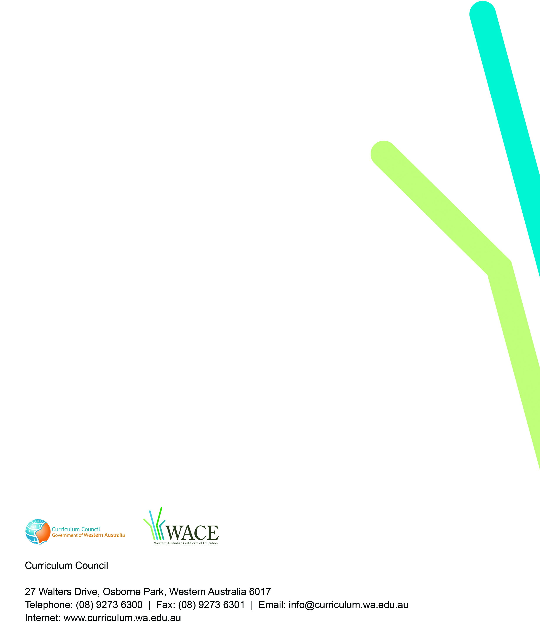
TRIM: 2009/8136[v4]

